**DAY 4 - BUILDING DYNAMIC FRONTEN COMPONENTFOR OUR MARKETPLACE**

1. Product Listing Component:

• Render product data dynamically in a grid layout.

•PREPARED BY AMEEN ALAM 4

DAY 4 - BUILDING DYNAMIC FRONTEND COMPONENTS FOR YOUR MARKETPLACE

o Product Name

o Price

o Image

o Stock Status

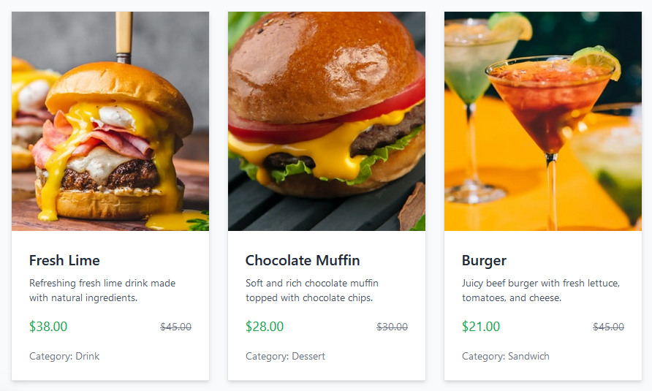

2. Product Detail Component:

• Create individual product detail pages using dynamic routing in Next.js.

• Include detailed fields such as:

o Product Description

o Price

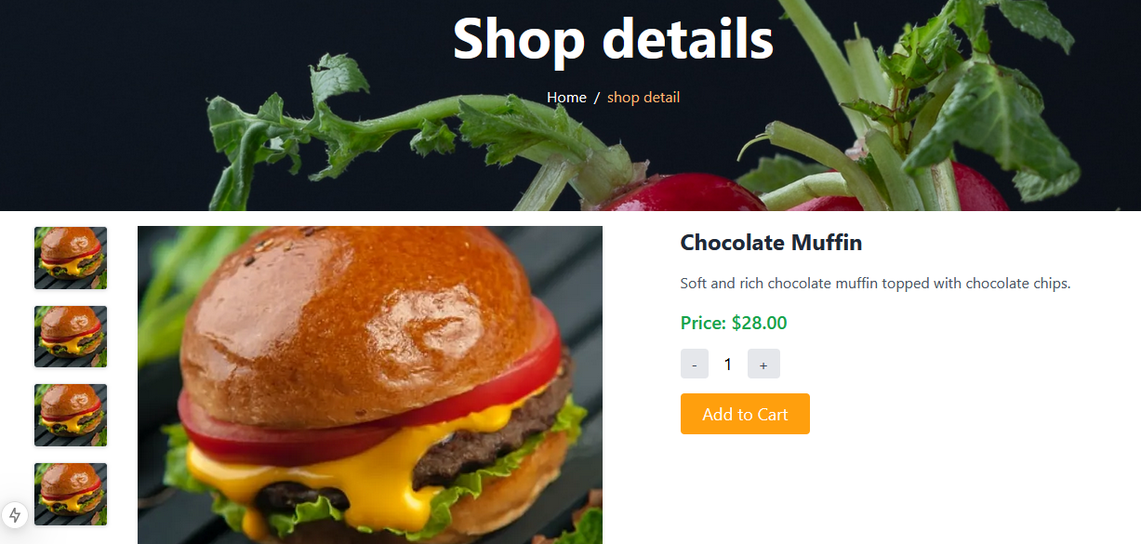

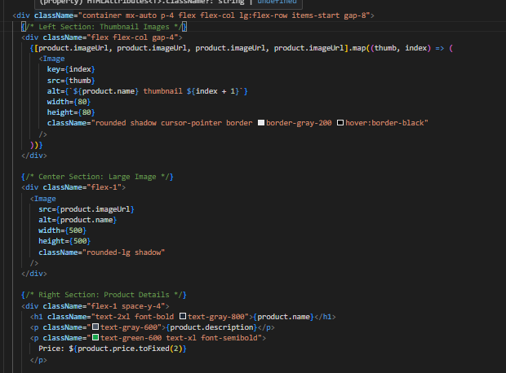

4. Search Bar:

• Implement search functionality to filter products by name or tags.

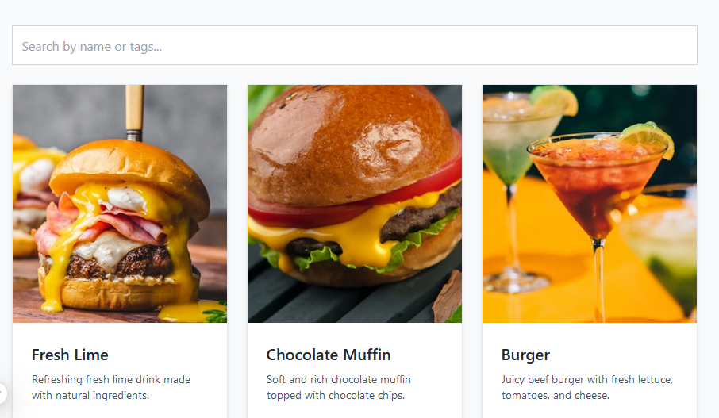

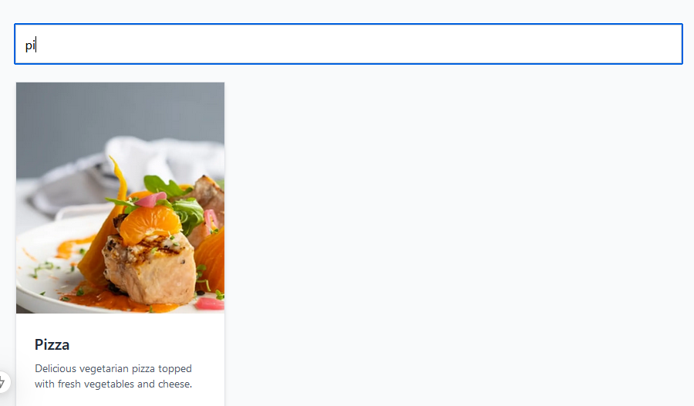

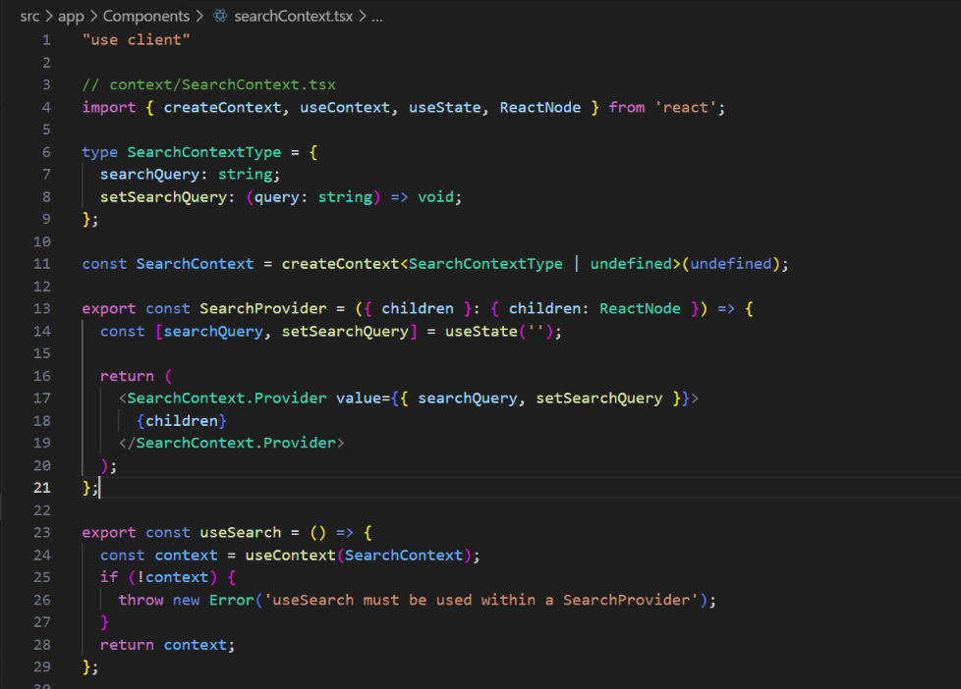

5. Cart Component:

• Display added items, quantity, and total price.

• Use state management for tracking cart items.



